Name : Muhammad Abubakar

Roll no : 21f-9278

SECTION : BCS 1B

**1ST PAGE**

<!DOCTYPE html>

<html lang="en">

<head>

<style>

* {

box-sizing: border-box;

}

body {

font-family: Arial;

}

/* Style the header */

header {

background-color: Red;

padding: 30px;

text-align: center;

font-size: 35px;

color: white;

}

/* Create two columns/boxes that floats next to each other */

nav {

float: left;

width: 30%;

height: 440px;

background: Lime;

padding: 40px;

}

/* Style the list inside the menu */

nav ul {

list-style-type: none;

padding: 2px;

}

article {

float: left;

padding: 20px;

width: 70%;

background-color: blue;

height: 440px;

}}

// Responsive layout - makes the two columns/boxes stack on top of each other instead of next to each other, on small screens

@media (max-width: 600px) {

nav, article {

width: 100%;

height: auto;

}

}

</style>

</head>

<body>

<header><img src="photo.jpeg" style ="float:right;width:140px;height:140px">

<h3 style = "text-align:left">MY PORTFOLIO </h3>

</header>

<section>

<nav>

<ul>

<h3 style = "text-align:left"><p style = "background-color:black;color:white;text-align:center">LINKS</p></h3>

<a href="file:///C:/Users/FINE/Desktop/website/2nd%20page.html"><p style ="text-align:center;color:black;">PERSONAL STATEMENT</p></a>

<a href="file:///C:/Users/FINE/Desktop/website/3rd%20page.html"><p style ="text-align:center;color:black;">PROJECTS</p></a>

</ul>

</nav>

<article>

<h2 style = "background-color:grey">ABOUT ME</h2>

<pre style="font-size:180%;color:white">Hi, I am Abubakar Nofal from Sargodha.

I was born on 16th may,2003.

This is my first portfolio website.

i have done my matriculation from <b>Sargodha</b> and fsc from <b>PGC</b>

I am vey glad that i got admission in <b style = color:red;>FAST UNIVERSITY</b>

I choose BSCS as my career as i have interest in computers

and mobile phones and it is also emerging field.

Hope you like my first website.</pre>

</article>

</section>

</body>

</html>

**2ND PAGE**

<html>

<head>

<h1 style="text-align:center;background-color:black;color:white;">2ND PAGE</h1>

<h2 style="background-color:red;">MY PERSONAL STATEMENT</h2>

</head>

<body>

<h1 style="background-color:tomato;color:white;">Introduction</h1>

<pre style="font-size:200%;border:solid Tomato;background-color:aqua">My name is M.Abubakar Nofal.I am a MUSLIM from religion.

<img src="intro.png" style ="float:right;width:200;height:200">

I am interested in computers and IT field so I have chosen BSCS as my career.

As fast is famous for it's IT field studies and CS so i gave their entry test

and luckily got selected for admission.

Before coming to university their were many thoughts about the university

which came in my mind that what will i do after this degree.

But after coming to university i am thinking how to get good grade in <br/><b>PROGRAMMING AKA PF :)</b>

BUT I am sure that after completing my degree i will get good job.</pre>

<h2 style="background-color:blue;color:white;">MY PASSION</h2>

<pre style="font-size:190%;border:solid Blue;background-color:firebrick;color:white;"><img src="passion.jpg" style ="float:right;width:200;height:200">My passion is all about computers and software.

I love to play games and promote E sports in pakistan.

i play battleroyale games and open world games like PUBG,GTA 5 etc <br/>and play their tournaments.

I lost some tournaments and also won some tournaments.

I have also joined FAST E gaming society to polish my E gaming skills.

In the future i will also try to get into E sports as it is emerging in pakistan. </pre>

<h3 style="background-color:green;color:white;">MY GOALS OF LIFE</h3>

<pre style="font-size:200%;border:solid green;background-color:gold;color:black"><img src="goals.jfif" style ="float:right;width:400;height:700">I have not specified my goals but my main goals are:

<dl>

<dt>Master programming and computer software</dt>

<dd>- I don't know how:(</dd>

<dt>Go on a trip with family to another country</dt>

<dd>- May be after graduation</dd>

<dt>Learn how to play guitar :)</dt>

<dd>Not so interested in it ...</dd>

</dl>

</pre>

<a href="file:///C:/Users/FINE/Desktop/website/1st%20page.html"><p style ="text-align:center">1ST MAIN PAGE</p></a>

<a href="file:///C:/Users/FINE/Desktop/website/3rd%20page.html"><p style ="text-align:center">3RD PAGE MY PROJECTS</p></a>

</body>

</html>

**3RD PAGE**

<html>

<head>

<h1 style="text-align:center;background-color:blue;color:white;">PROJECTS PAGE</h1>

</head>

<style>

body {

background-image:url('background.jpg');

background-repeat: no-repeat;

background-attachment: fixed;

background-size: cover;

}

</style>

<h1 style="background-color:lime;color:black;">MAJOR ACHIEVEMENTS</h1>

<pre style="border: solid lime;color:white;font-size:200%"><img src="6.gif" style ="float:right;width:400;height:249">I don't have any major achivements till now.

But i am trying my best to achive my goals for future.

My major aim is to become a game developer and web developer.

But for now in FAST university i am trying my best to get <br/>good grades especially in PF:).

In the future my aim will be to become good programmer and get

a job in good company.

In the future i will try to make a good game or app.</pre>

<p style="text-align:center;background-color:red;color:white;font-size:400%;">THANKS I HOPE MY WEBSITE IS FINE</p>

<a href="file:///C:/Users/FINE/Desktop/website/1st%20page.html"><p style ="text-align:center;color:white">1ST MAIN PAGE</p></a>

<a href="file:///C:/Users/FINE/Desktop/website/2nd%20page.html"><p style ="text-align:center;color:white">2ND PAGE MY PERSONAL STATEMENT</p></a>

</body>

</html>

1ST PAGE

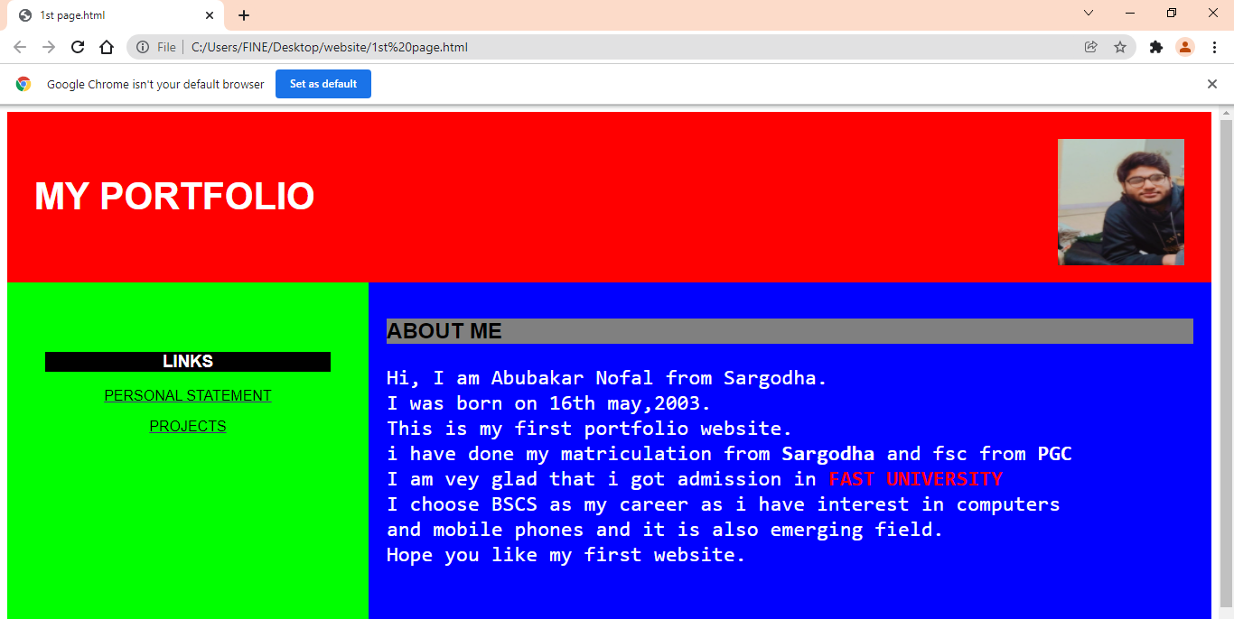

2ND PAGE

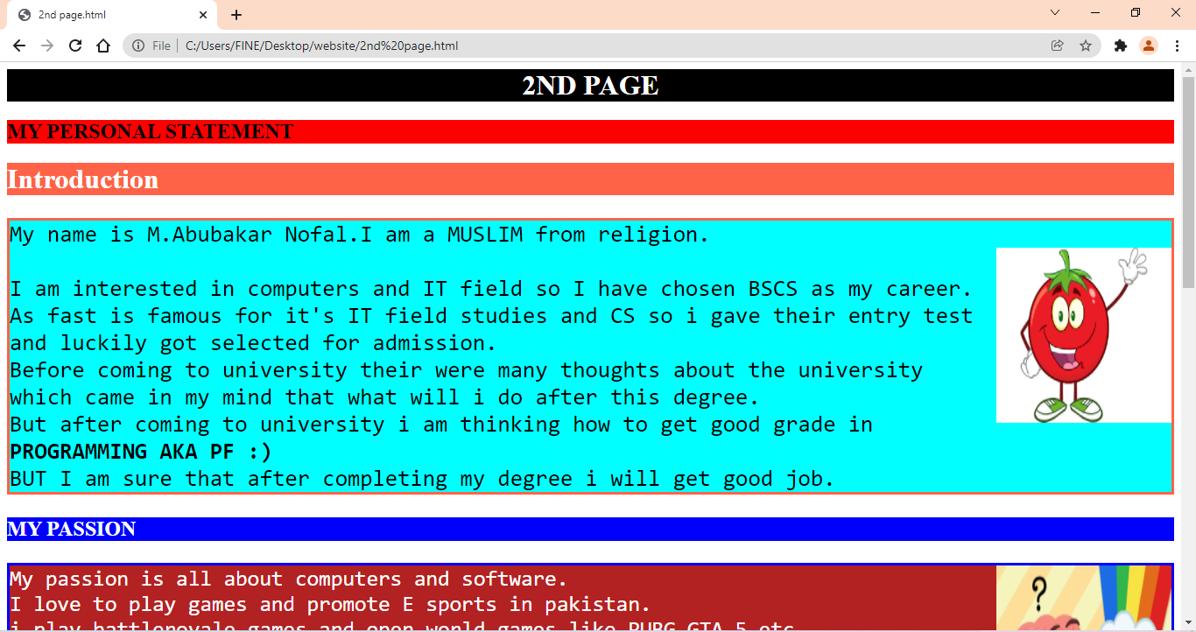

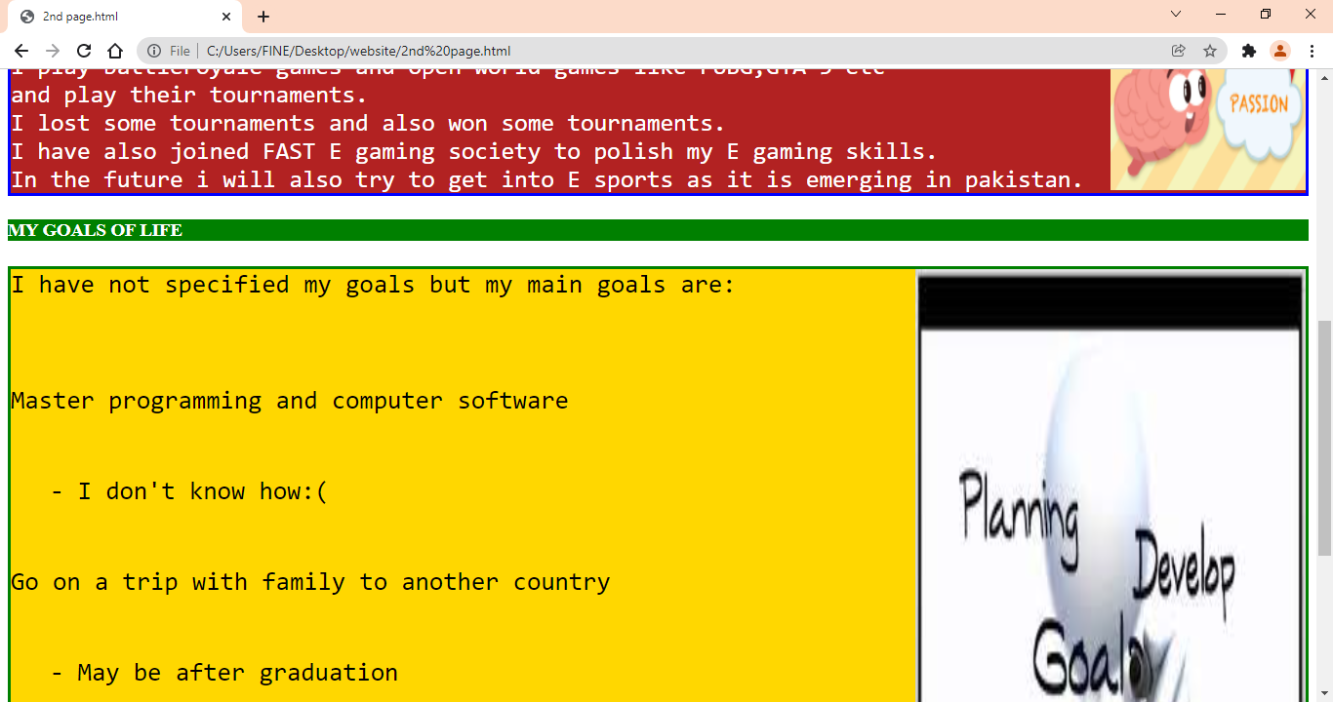

3RD PAGE

